SIMATS ENGINEERING
ASSESSMENT TOOL 1

COURSE NAME: INTERNET PROGRAMMING
COURSE CODE: CSA43
NAME: G.CHAKRADHAR
REG.NO.: 192311439

COURSE OUTCOME COVERED

CO 3: Implement dynamic web applications by utilizing DOM-based client-side scripting and employing Java Servlets for server-side request processing and response handling. (L3)

Assessment Tool : Scenario-Based Assessment

Weightage: 40%

QUESTIONS: Total Marks: 30

Question 1
Suppose that a college wants to develop an online student registration system where students submit their details through a web form, and the data is processed using a Java Servlet.
Explain the architecture of a servlet-based application. Design and implement a servlet to handle form data using both GET and POST methods. Describe the servlet life cycle (init, service, destroy) and justify which method is more appropriate for handling sensitive data.

Question 2
Suppose that a website requires users to log in and maintain their session across multiple pages after authentication.
Design a session management system using HttpSession and Cookies in Servlets. Explain how session tracking works in web applications and compare session-based tracking with cookies.

Question 3
Suppose that an e-commerce platform needs to store and retrieve product details from a database using a Java-based web application.
Design a JDBC-based application to connect to a database, insert product data, and retrieve it using SQL queries. Explain the JDBC architecture and describe the steps involved in database connectivity along with proper exception handling.

Code of Conduct:

I G.CHAKRADHAR(192311439) certify that this submission is my original work and that I have adhered to the guidelines specified for this assessment.
I understand that any violation of academic integrity rules will result in disciplinary action.

Signature of the student: 

RUBRICS FOR CALCULATION:

Criteria | Weightage (%) | Level 4 (Exemplary) | Level 3 (Proficient) | Level 2 (Developing) | Level 1 (Beginning)
Understanding of Scenario | 20% | Demonstrates clear and complete understanding of the scenario and context | Shows good understanding with minor gaps | Partial understanding; misses key aspects | Misinterprets or fails to understand the scenario
Identification of Key Issues | 20% | Accurately identifies all relevant issues and factors involved | Identifies most key issues with minor omissions | Identifies limited issues; some irrelevant points | Unable to identify key issues
Application of Concepts | 25% | Applies appropriate concepts effectively to address the scenario | Applies concepts with minor errors | Limited or partially correct application | Unable to apply relevant concepts
Decision Making | 20% | Makes well-reasoned, logical decisions with strong rationale | Makes reasonable decisions with some justification | Makes weak decisions with limited justification | No clear decisions made or rationale provided
Clarity of Response | 15% | Response is clear, structured, and logically presented | Generally clear with minor issues | Somewhat unclear or poorly structured | Disorganized and difficult to understand

ANSWERS

Question-1

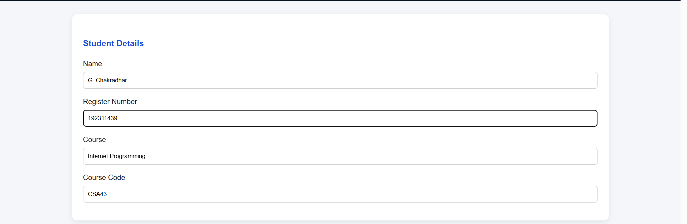

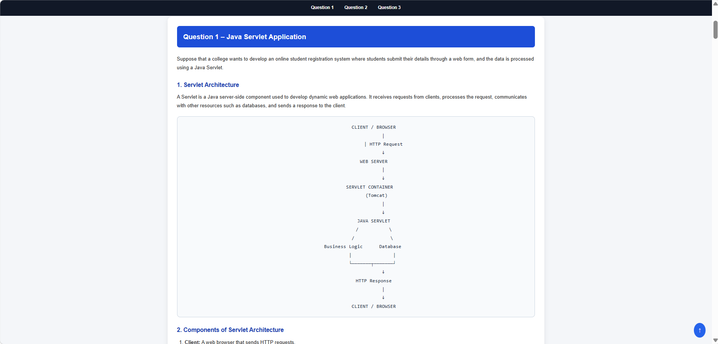

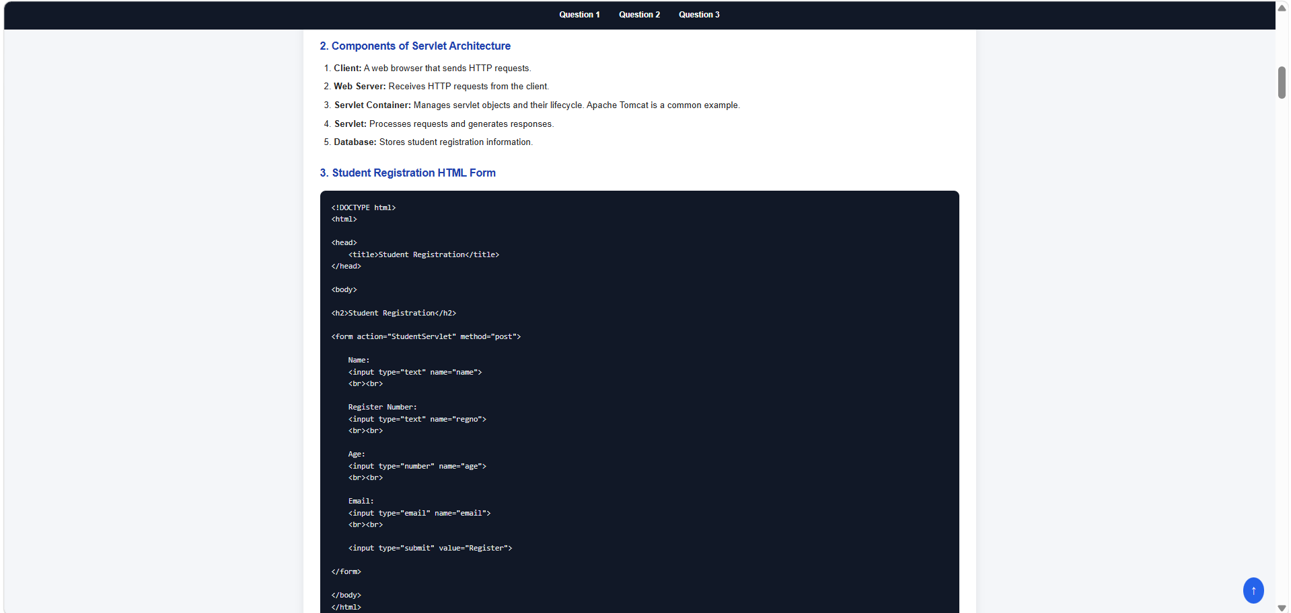

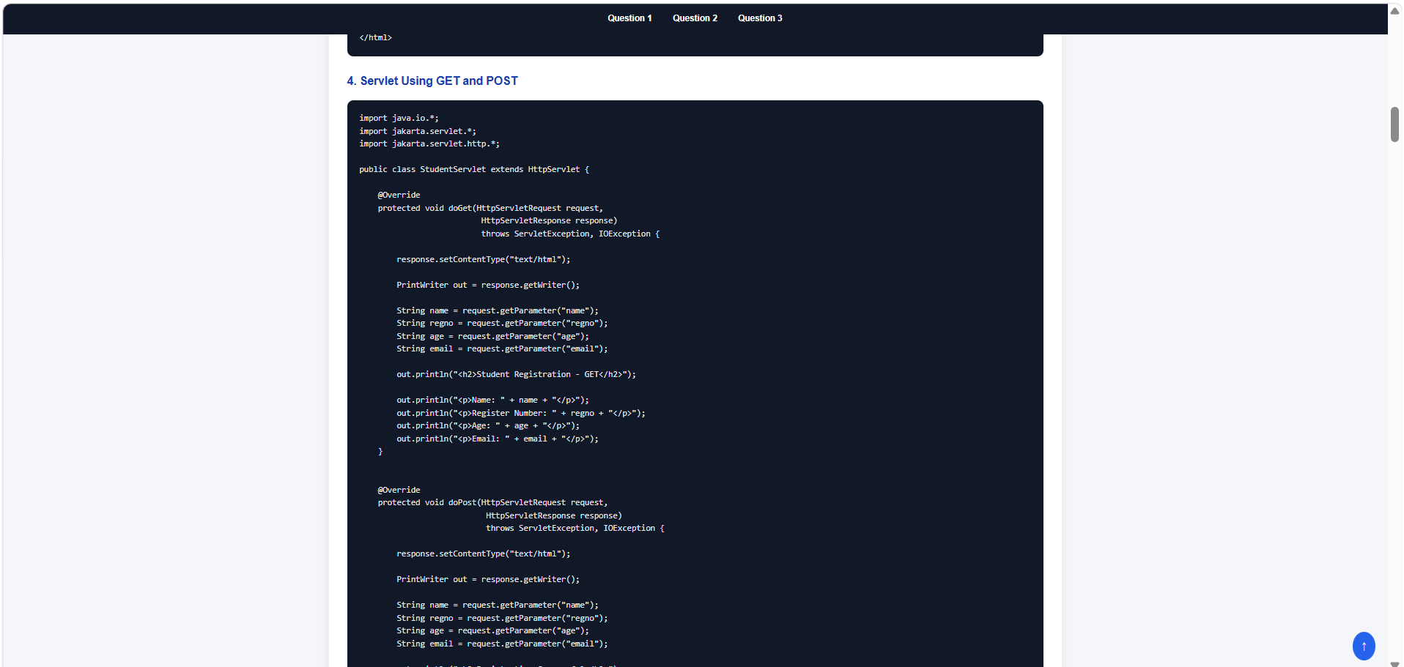

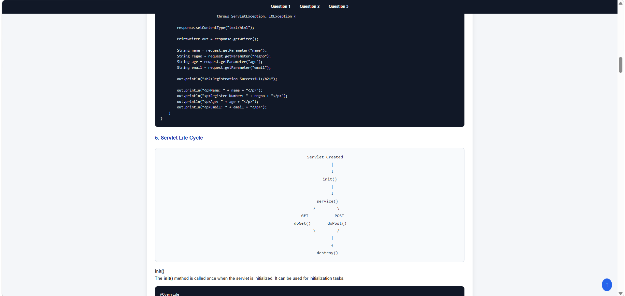

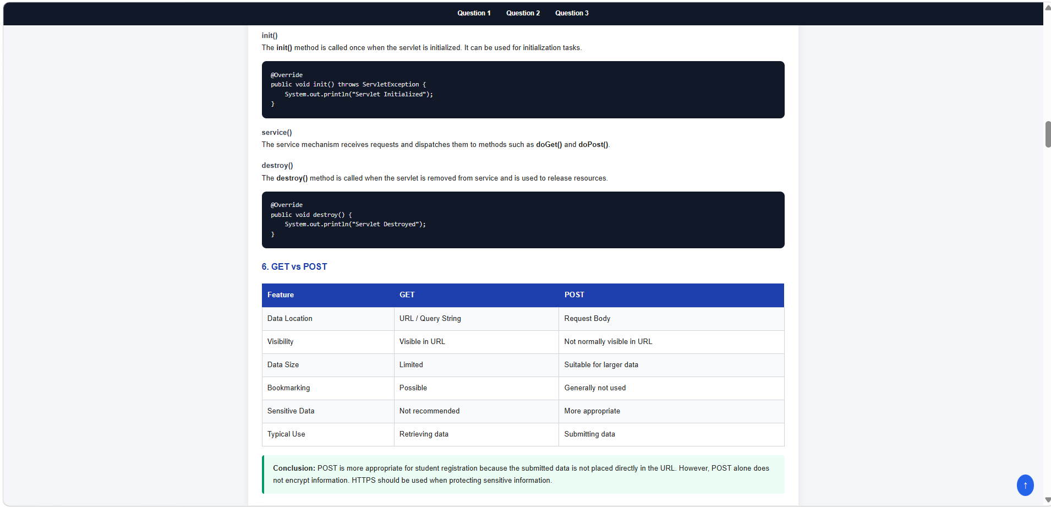
Question-2

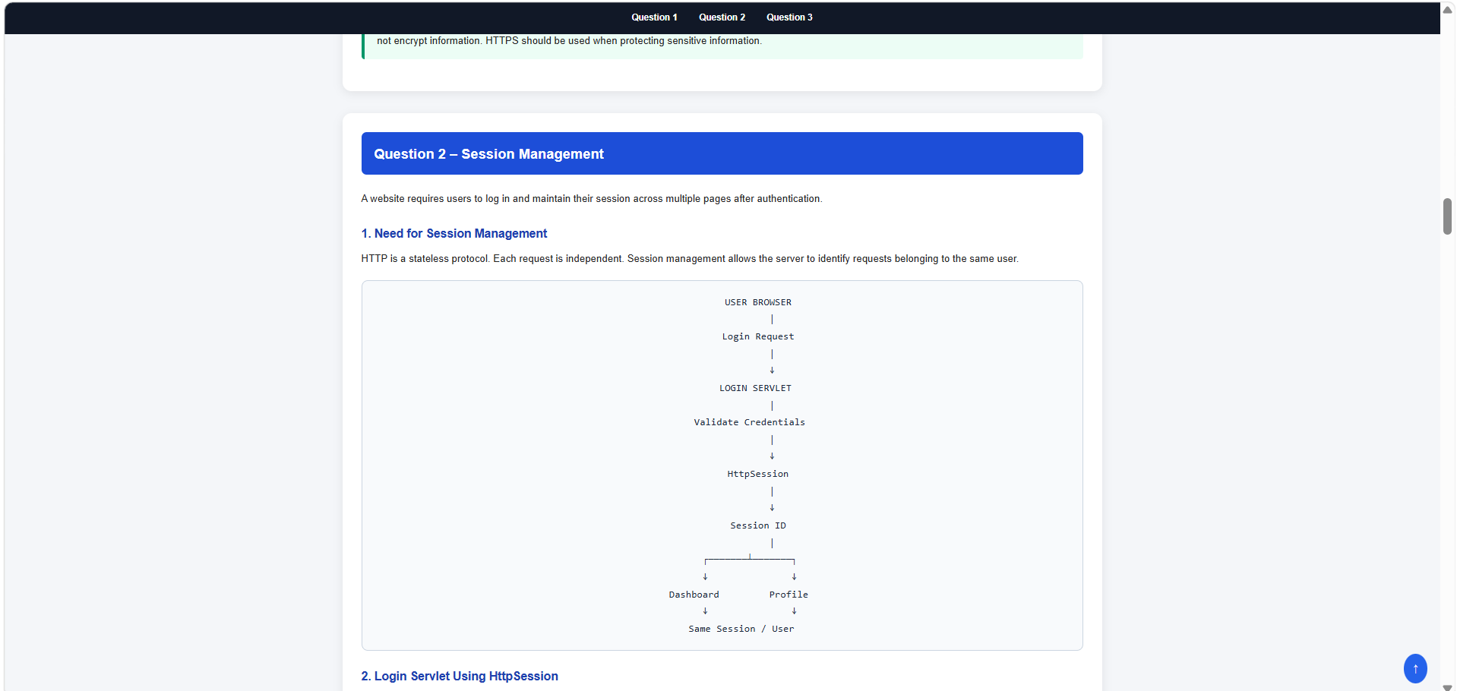

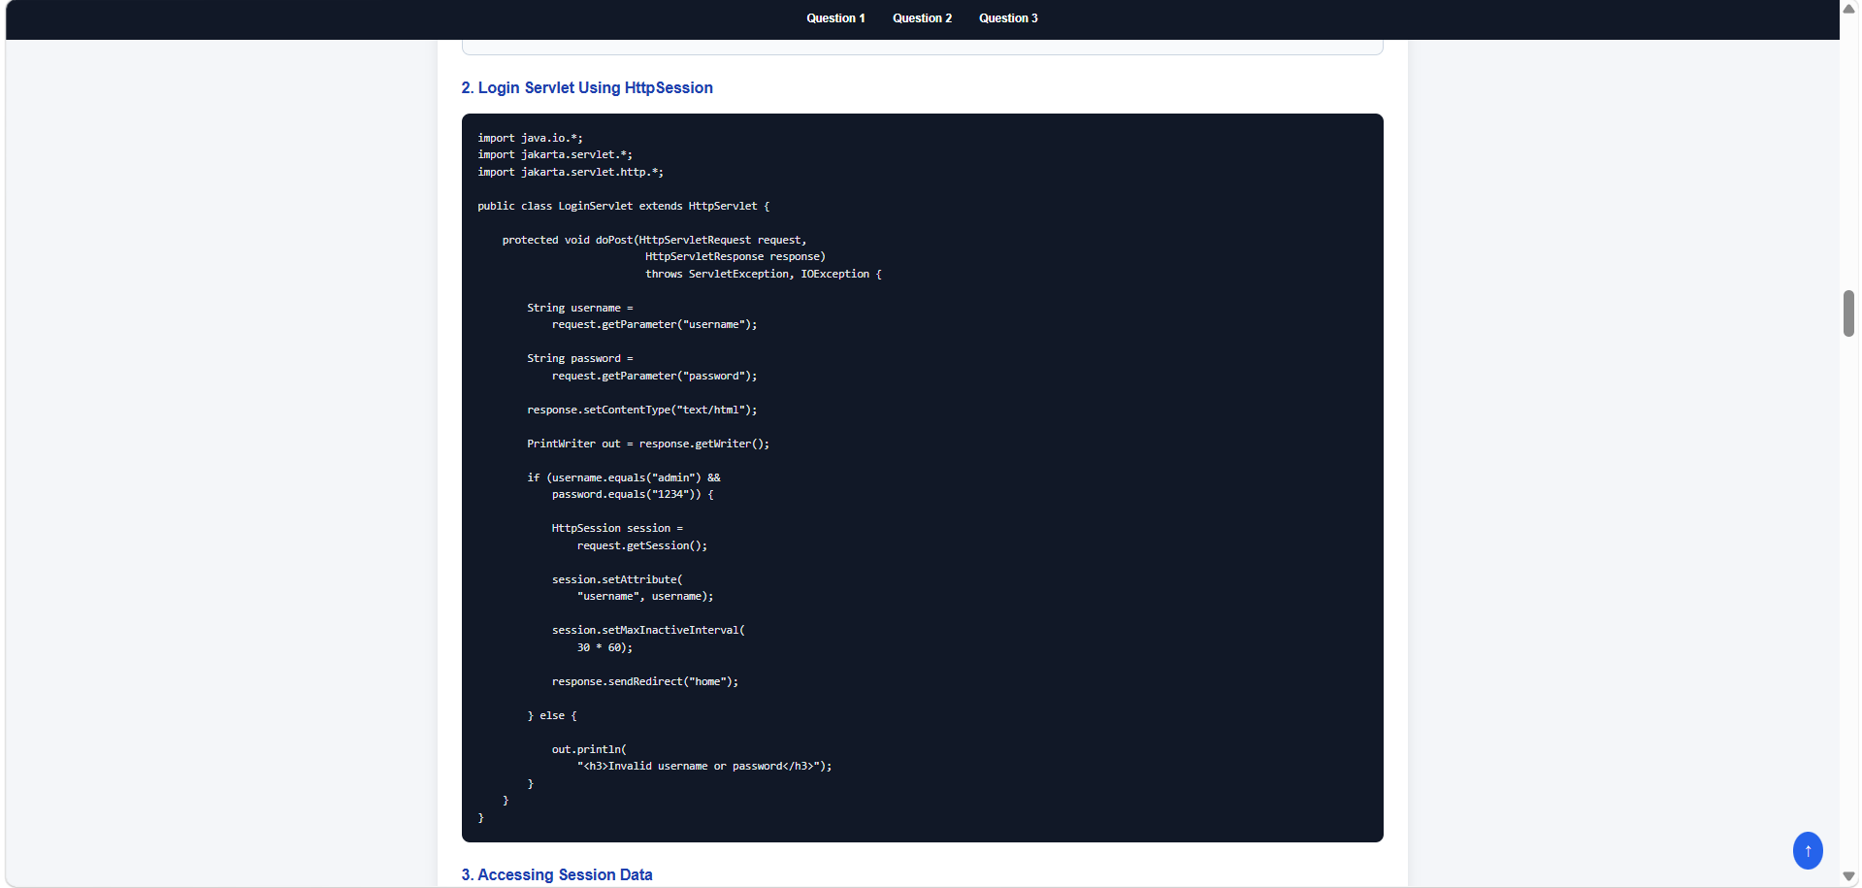

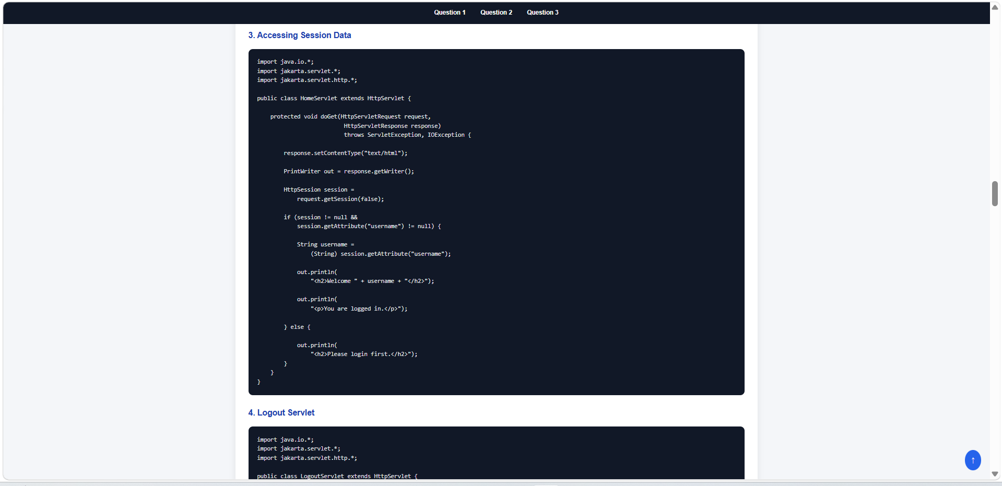

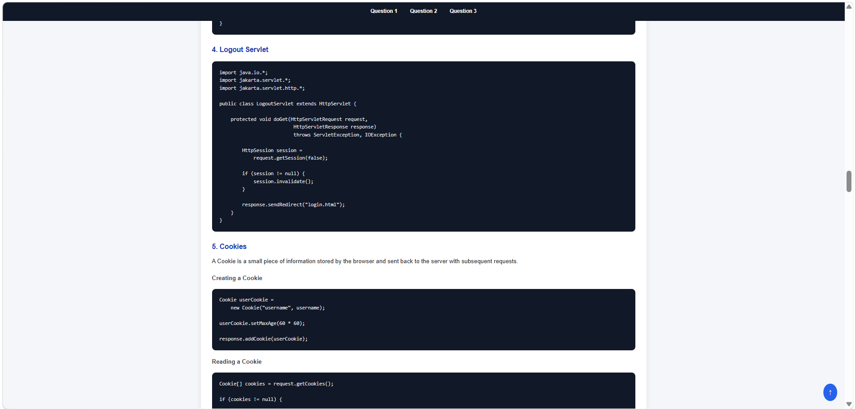

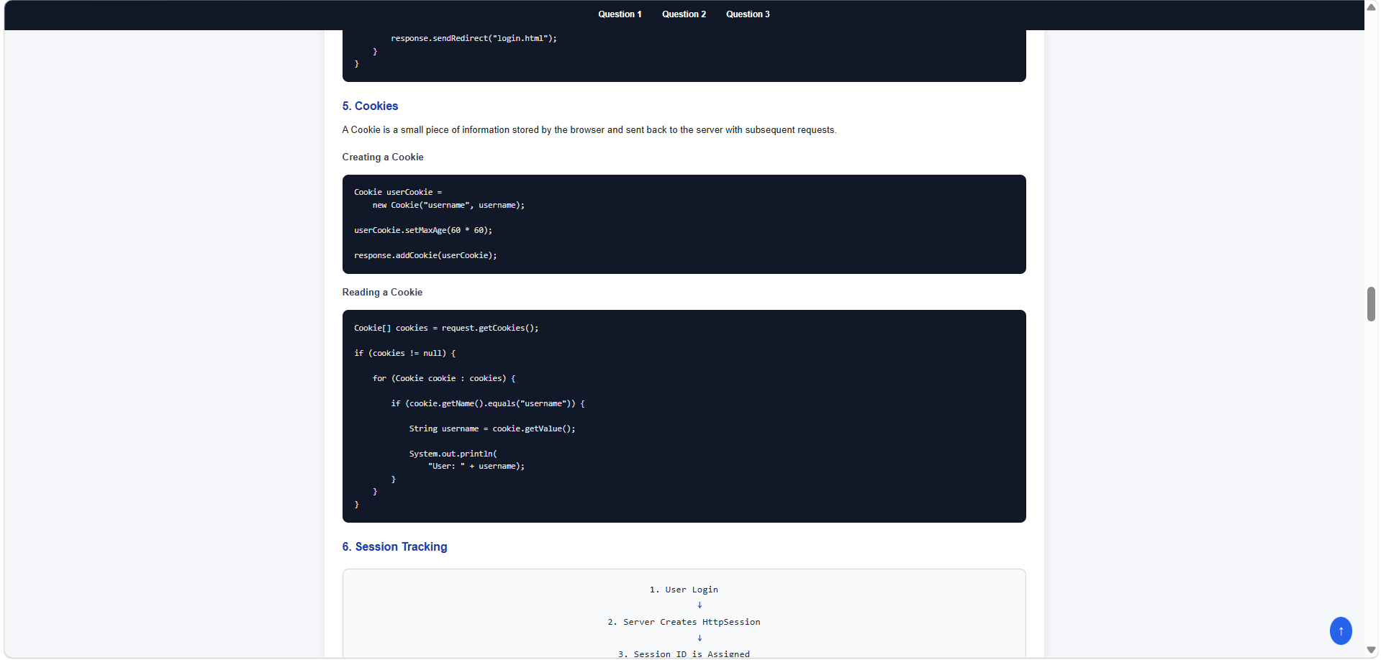

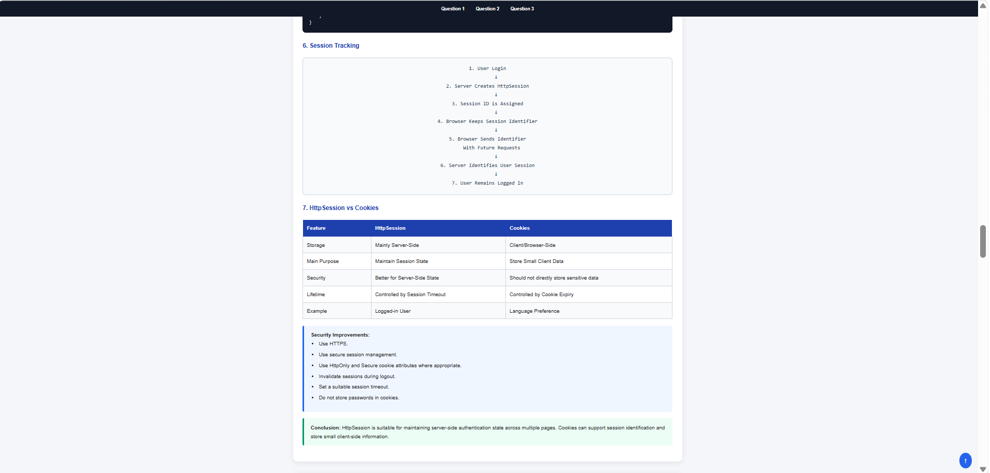

Question-3

